Brain TumorDetectionDataset

1. **Introduction to Brain Tumor** **Detection Using CNN**

Imagine a world where a clinician, armed with the keen eye of AI, can quickly and accurately identify tumors from intricate neuroimaging data. This is not science fiction, but the promise of transformative technology. Automated brain tumor detection holds the potential to revolutionize healthcare, offering:

* **Earlier Diagnosis:** Timely identification unlocks the door to early intervention, improving treatment outcomes and survival rates.
* **Enhanced Accuracy:** AI can analyze subtle patterns invisible to the human eye, reducing misdiagnosis and leading to more efficient resource allocation.
* **Streamlined Workflow:** Automated tumor detection can alleviate the burden on radiologists, enabling faster diagnosis and quicker response.

1. **About the Brain MRI Images dataset:**

* The dataset contains 2 folders: yes and no which contains 253 Brain MRI Images. The folder yes contains 155 Brain MRI Images that are tumorous, and the folder no contains 98 Brain MRI Images that are non-tumorous.

**3.Libraries we used:**

* **TensorFlow (tf):** The primary framework for building and training deep learning models.
* **Keras:** A high-level API within TensorFlow, providing user-friendly tools for model creation and training.
* **NumPy (np):** A fundamental library for numerical computations and array manipulation, essential for handling image data.
* **OpenCV (cv2):** A powerful library for real-time computer vision tasks, used here for image processing and manipulation.
* **Scikit-learn:** Provides tools for machine learning tasks, as data splitting and evaluation.

**3.Specific Module Imports:**

* **Conv2D, Input, ZeroPadding2D, BatchNormalization, Activation, MaxPooling2D, Flatten,** **Dense:** Key layers for building convolutional neural networks (CNNs) in Keras, used to construct your model architecture.
* **Model, load_model:** Classes for creating and loading Keras models.
* **TensorBoard, ModelCheckpoint:** Callbacks for monitoring training progress and saving the best model checkpoints.
* **train_test_split, f1_score, shuffle:** Functions for splitting data, evaluating model performance, and shuffling data for randomization.
* **imutils:**A library for convenient image processing operations.
* **matplotlib.pyplot (plt):** Used for creating visualizations, such as plotting images or results.
* **time:** For time-related tasks, potentially used for tracking execution time or timestamps.
* **os:** For interacting with the operating system, likely used for file and directory operations.

**Data Augmentation: Creating More From Less**

Data augmentation is a powerful technique in machine learning, particularly for tasks like image and audio recognition. It essentially involves artificially **manipulating existing data points to create new ones with the same label**. This "augmented" data helps to:

**1. Increase the size and diversity of your dataset:** With limited data, your model might overfit, memorizing specific patterns instead of learning generalizations. Data augmentation provides more training examples, diversifying the dataset and ensuring the model learns broader features.

**2. Improve model generalizability:** The real world presents images and sounds at different angles, with varying brightness, noise, and other distortions. Data augmentation mimics these variations, preparing the model to recognize patterns even under different conditions.

**3. Reduce overfitting:** Overfitting occurs when your model memorizes specific training examples, failing to generalize to unseen data. By introducing a wider range of examples, data augmentation prevents the model from overfitting to idiosyncrasies in the original dataset.

Here are some common data augmentation techniques

* Image Augmentation:
  + **Geometric transformations:** Rotating, scaling, shifting, and shearing images.
  + **Color alterations:** Changing brightness, contrast, hue, and saturation.
  + **Adding noise:** Simulating real-world image imperfections like blurring or pixelation.
  + **Cropping and flipping:** Extracting smaller regions or flipping images horizontally or vertically.

**Jump into code:**

**We have two different code files , one for augmentation , and for the main code starting with the augmentation one**

Here the main library we’re using is keras where we import form it the imgeDataGenerator which going to be used to augment data

**Starting of the data augmentation**

1. The function takes three arguments:
   * file_dir: The directory path where the original images are located.
   * n_generated_samples: The number of augmented samples to generate for each original image.
   * save_to_dir: The directory path where the augmented images will be saved.
2. The function initializes an instance of the ImageDataGenerator class from the Keras library. This class provides various image transformation methods for data augmentation.
3. The ImageDataGenerator object is configured with several transformation parameters, including rotation range, width and height shift range, shear range, brightness range, and flipping options. These parameters control the types and degrees of transformations applied to the images during augmentation.
4. The function then iterates through the files in the file_dir directory using the listdir function. For each file, it performs the following steps:
   * Loads the image using the OpenCV library (cv2.imread).
   * Reshapes the image to add an extra dimension to match the input shape expected by the data_gen.flow method.
   * Sets the save prefix for the generated samples based on the original filename.
   * Utilizes a loop that generates n_generated_samples augmented images by calling the data_gen.flow method. The augmented images are saved in the save_to_dir directory with the save prefix and in JPEG format.
   * The loop breaks once the desired number of generated samples has been reached.

1. providing the directory paths for the original images (yes_path and no_path) and specifying the number of generated samples to create for each class. The augmented images are saved in the augmented_data_path directory.
2. Remember that 61% of the data (155 images) are tumorous. And, 39% of the data (98 images) are non-tumorous. So, in order to balance the data we can generate 9 new images for every image that belongs to 'no' class and 6 images for every image that belongs the 'yes' class.

**Result of the Data Augmentation**

We made a function to calculate the percentage of the positive percentage and the negative images

**Number of examples: 2065**

**Percentage of positive examples: 52.54237288135593%, number of pos examples: 1085**

**Percentage of negative examples: 47.45762711864407%, number of neg examples: 980**

**The main code for Brain Tumor Detection**

**Importing libraries**

**Data Preparation & Preprocessing**

First of all we need to crop the part that contains only the brain since any processing on black pixels that have nothing to do with the brain will only result in bias and low accuracy

In order to crop the part that contains only the brain of the image, I used a cropping technique to find the extreme top, bottom, left and right points of the brain.

The next code utilizes image processing techniques to isolate the brain region from the background and remove unnecessary information.

Also  the visualization feature of the function, which allows for a clear comparison between the original image and the cropped image. This can aid in understanding the effectiveness of the cropping process and visually showcase the region of interest.

1. The function crop_brain_contour takes two arguments:
   * image: The input image in BGR format.
   * plot (optional): A boolean flag indicating whether to display a plot of the original and cropped images. By default, it is set to False.
2. The code begins by converting the input image to grayscale using cv2.cvtColor and applying a Gaussian blur using cv2.GaussianBlur. This helps reduce noise and smoothens the image.
3. A thresholding operation is performed on the grayscale image using cv2.threshold. This converts the image into a binary format, where pixel values above a certain threshold are set to white, and pixel values below the threshold are set to black.
4. A series of morphological operations, specifically erosion and dilation, are applied to remove any small regions of noise. These operations help to refine the binary image and improve the quality of the brain contour.
5. Using cv2.findContours, the function identifies the contours in the thresholded image. The largest contour is selected as the brain contour using max(cnts, key=cv2.contourArea).
6. The extreme points of the brain contour, i.e., the leftmost, rightmost, topmost, and bottommost points, are found using NumPy indexing and stored in extLeft, extRight, extTop, and extBot variables, respectively.
7. A new image is cropped out of the original image using the four extreme points. This is achieved by indexing the original image with the appropriate coordinates: image[extTop[1]:extBot[1], extLeft[0]:extRight[0]].
8. If the plot flag is set to True, the function displays a plot with two subplots:
   * The first subplot shows the original image using plt.imshow.
   * The second subplot shows the cropped image using plt.imshow.
   * Various formatting options are applied to remove axes labels and ticks.

**In order to better understand what it's doing, let's grab an image from the dataset and apply this cropping function to see the result:**

**Load up the data:**

The following function takes two arguments, the first one is a list of directory paths for the folders 'yes' and 'no' that contain the image data and the second argument is the image size, and for every image in both directories and does the following:

1. Read the image.

2. Crop the part of the image representing only the brain.

3. Resize the image (because the images in the dataset come in different sizes (meaning width, height and # of channels). So, we want all of our images to be (240, 240, 3) to feed it as an input to the neural network.

4. Apply normalization because we want pixel values to be scaled to the range 0-1.

5. Append the image to X and its label to y

After that, Shuffle X and y, because the data is ordered (meaning the arrays contains the first part belonging to one class and the second part belonging to the other class, and we don't want that).

Finally, Return X and y

**Load up the data that we augmented earlier in the Data Augmentation notebook**

As we see, we have 2065 images. Each images has a shape of **(240, 240, 3)=(image_width, image_height, number_of_channels)**

**Plot sample images:**

**1. Distribution of Tumor and Non-Tumor Samples**

**2. showing some negative to positive images**

**3. deeper look into the data**

**Trying visually detected the brain tumor**

1. The function detect_tumor takes two arguments:
   * image: The input image, which can be in either grayscale or BGR format.
   * plot (optional): A boolean flag indicating whether to display a plot of the image with the detected tumor regions. By default, it is set to False.
2. The code first checks if the image is already in grayscale by examining the shape of the image. If the shape has only two dimensions, it is assumed to be grayscale. Otherwise, the image is converted to grayscale using cv2.cvtColor with the conversion code cv2.COLOR_BGR2GRAY.
3. Gaussian blur is applied to the grayscale image using cv2.GaussianBlur to reduce noise and smoothen the image.
4. A binary mask is created by thresholding the blurred image using cv2.threshold. Pixels with intensity values above a certain threshold (190 in this case) are set to white, while pixels below the threshold are set to black.
5. Contours are extracted from the binary mask using cv2.findContours. The contours represent the boundaries of potential tumor regions.
6. Bounding boxes are drawn around each contour using cv2.rectangle. The coordinates of the bounding box are determined using cv2.boundingRect.
7. If the plot flag is set to True, the function displays the image with the detected tumor regions highlighted. The image is converted from BGR to RGB format using cv2.cvtColor, and then displayed using plt.imshow. A title is added to the plot using plt.title.

We tried to do a rectangle shape around the tumor if the image MRI contains a tumor, here is the first result we got using threshold 128,255

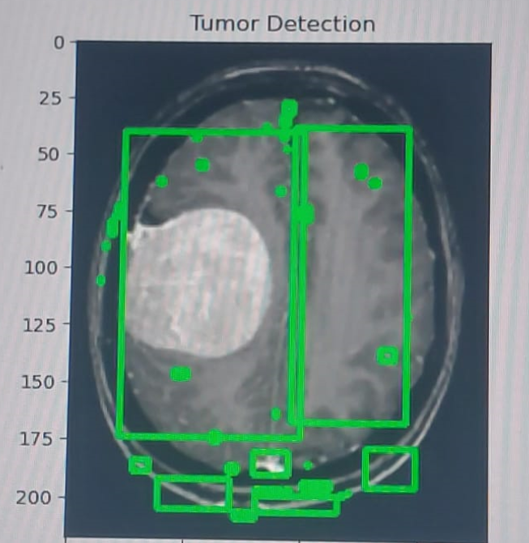

As shown the detected areas were not just the tumor position so we changed the threshold and this was the output

**Split the data**

Using a function called **split_data** that takes input data **X** and labels **Y**.

This function splits them into:

* Training
* Validation
* Test sets

using the **train_test_split** function.

The used split was:

1. 70% of the data for 🡺 training.
2. 15% of the data for 🡺 validation.
3. 15% of the data for 🡺 testing.

**Note:**

The choice of how to split your data into training, validation, and test sets depends on various factors, (70% training, 15% validation, 15% testing) is a common and reasonable choice in many cases.

For example, the majority of the data is used for training the model which is important because it allows the model to learn patterns and relationships within the data.

**Data information**

**Building a convolutional neural network model:**

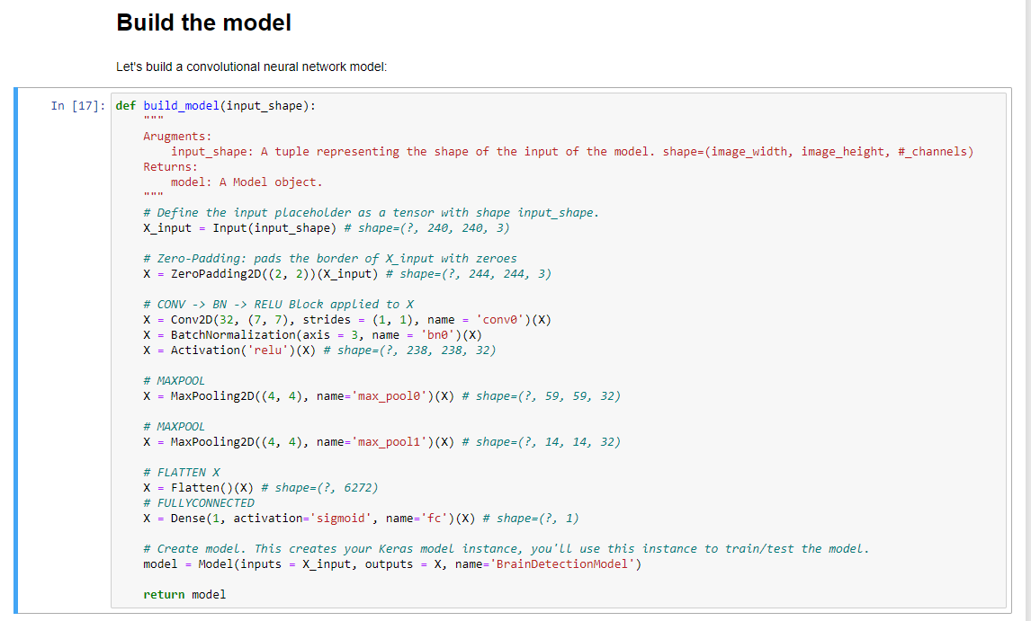

**build_model** function 🡺 defines a simple convolutional neural network (CNN) for brain detection using Keras.

Each input x (image) has a shape of (240, 240, 3) and is fed into the neural network.

It goes through the following layers:

1. A Zero Padding layer with a pool size of (2, 2).
2. A convolutional layer with 32 filters, with a filter size of (7, 7) and a stride equals to 1.
3. A batch normalization layer to normalize pixel values to speed up computation.
4. A ReLU activation layer.
5. A Max Pooling layer with f=4 and s=4.
6. A Max Pooling layer with f=4 and s=4, same as before.
7. A flatten layer in order to flatten the 3-dimensional matrix into a one-dimensional vector.
8. A Dense (output unit) fully connected layer with one neuron with a sigmoid activation (since this is a binary classification task).

This architecture is suitable for binary classification tasks like brain detection.

**Model compilation:**

It is the step that prepares the model to learn from a given dataset and adjust its internal parameters (weights and biases) to optimize its performance by specifying the optimizer, loss function, and evaluation metrics.

**Loss Function**: The loss function quantifies the difference between the predicted output of the model and the true output. It measures the model's performance during training

**Optimizer:** determines how the model's weights are updated during training.



We used the Adam optimizer, which is a popular optimization algorithm that combines the benefits of the AdaGrad and RMSProp optimizers.

The loss function is set to 'binary_crossentropy', which is commonly used for binary classification problems. It measures the difference between the predicted probabilities and the true labels, with the goal of minimizing this difference during training.

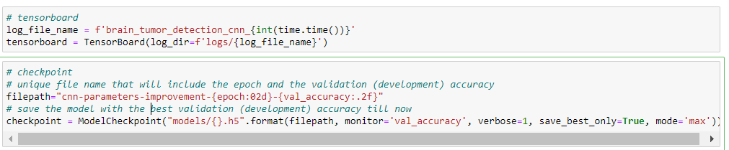

**log_file_name**: It is a string variable generated based on the current timestamp, providing a unique name for the TensorBoard log directory.

**TensorBoard**: It is a Keras callback,is used for visualizing metrics such as loss and accuracy during the training process.

The **log_dir** parameter specifies the directory where TensorBoard will write its log files.

**filepath**: It is a string specifying the format for the saved model file names. **{epoch:02d}** is a placeholder for the epoch number

**{val_accuracy:.2f}** is a placeholder for the validation accuracy formatted as a floating-point number with two decimal places.

**ModelCheckpoint**: It is a Keras callback that saves the model after every epoch. The **monitor** parameter specifies the metric to monitor for saving the best model, and **mode** determines whether to maximize or minimize the monitored metric.

So ModelCheckpoint is used to save the model's parameters during training. It helps in creating checkpoints at regular intervals and only saves the model if the monitored metric (in this case, validation accuracy) improves.

Used later in loading the best model based on validation performance rather than the last epoch. It is especially useful for preventing overfitting.

**Train the model:**

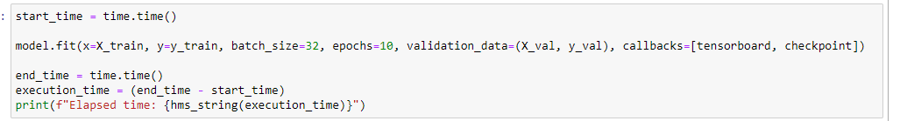

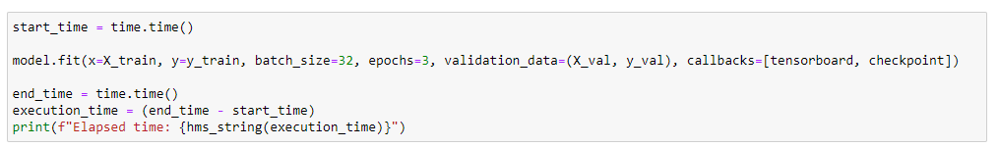

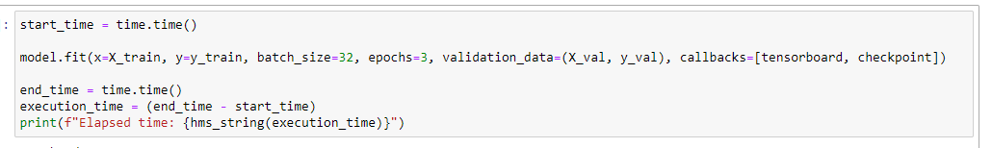

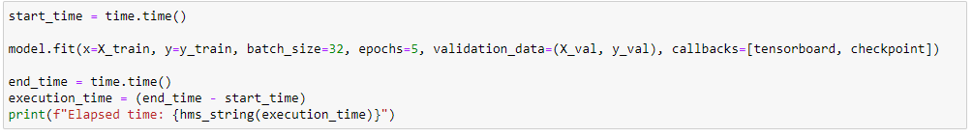

Training our neural network model multiple times with different numbers of epochs, with measuring the elapsed time for each training session. This is a common practice for monitoring the time it takes to train a model under different configurations.

Another way we could use:

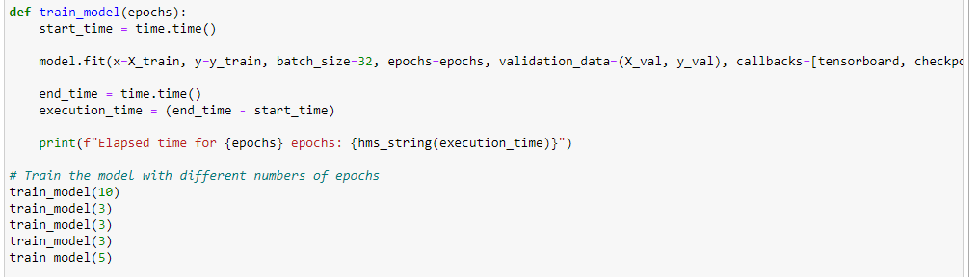

This is a more efficient way to structure the previous code by avoiding the repetitions.

**Plot Loss & Accuracy**

**Note: Since we trained the model using more than model.fit() function call, this made the history only contain the metric values of the epochs for the last call (which was for 5 epochs), so to plot the metric values across the whole process of trianing the model from the beginning, I had to grab the rest of the values.**

**Evaluating results**

Let's experiment with the best model (the one with the best validation accuracy):

Concretely, the model at the 23rd iteration with validation accuracy of 91%

**Load the best model**

**Evaluate the best model on the testing data:**

**Accuracy of the best model on the testing data:**

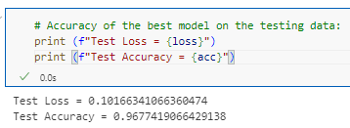

Confusion matric and F1 score

A confusion matrix is typically a square matrix with rows and columns representing the different classes in your classification problem. It is divided into four sections:

**True Positives (TP):** This represents the cases where the model correctly predicted the positive class (e.g., tumor) when it was actually positive.

**True Negatives (TN):** This represents the cases where the model correctly predicted the negative class (e.g., non-tumor) when it was actually negative.

**False Positives (FP):** This represents the cases where the model incorrectly predicted the positive class (e.g., tumor) when it was actually negative.

**False Negatives (FN):** This represents the cases where the model incorrectly predicted the negative class (e.g., non-tumor) when it was actually positive.

The confusion matrix allows you to assess the model's performance in terms of these four categories. It helps you understand the types of errors the model is making and provides insights into its accuracy, precision, recall, and other evaluation metrics.

**F1 score** is a metric commonly used to evaluate the performance of a classification model, particularly in imbalanced datasets where the distribution of classes is uneven. It combines precision and recall into a single value that represents the model's overall accuracy.

The F1 score is calculated using the following formula:

F1 score = 2 * (precision * recall) / (precision + recall)

**Precision** is the ratio of true positives (TP) to the sum of true positives and false positives (FP). It measures the proportion of correctly predicted positive instances among all instances predicted as positive. Precision indicates how well the model predicts positive instances accurately.

**Recall**, also known as sensitivity or true positive rate, is the ratio of true positives (TP) to the sum of true positives and false negatives (FN). It measures the proportion of correctly predicted positive instances among all actual positive instances. Recall indicates how well the model captures positive instances.

The F1 score combines precision and recall by taking their harmonic mean. It provides a balanced measure of the model's ability to identify both positive and negative instances correctly. The harmonic mean emphasizes lower values, so the

F1 score is lower when either precision or recall is low.

The F1 score ranges from 0 to 1, with 1 representing the best possible value (perfect precision and recall), and 0 representing the worst value (poor precision or recall).

**Results Interpretation**

Let's remember the percentage of positive and negative examples:

Number of examples: 2065

Percentage of positive examples: 52.54237288135593%, number of pos examples: 1085

Percentage of negative examples: 47.45762711864407%, number of neg examples: 980

**As expectred, the percentage of positive examples are around 50%.**

**better way to visualize percentage of positive and negative examples**

**Conclusion**

